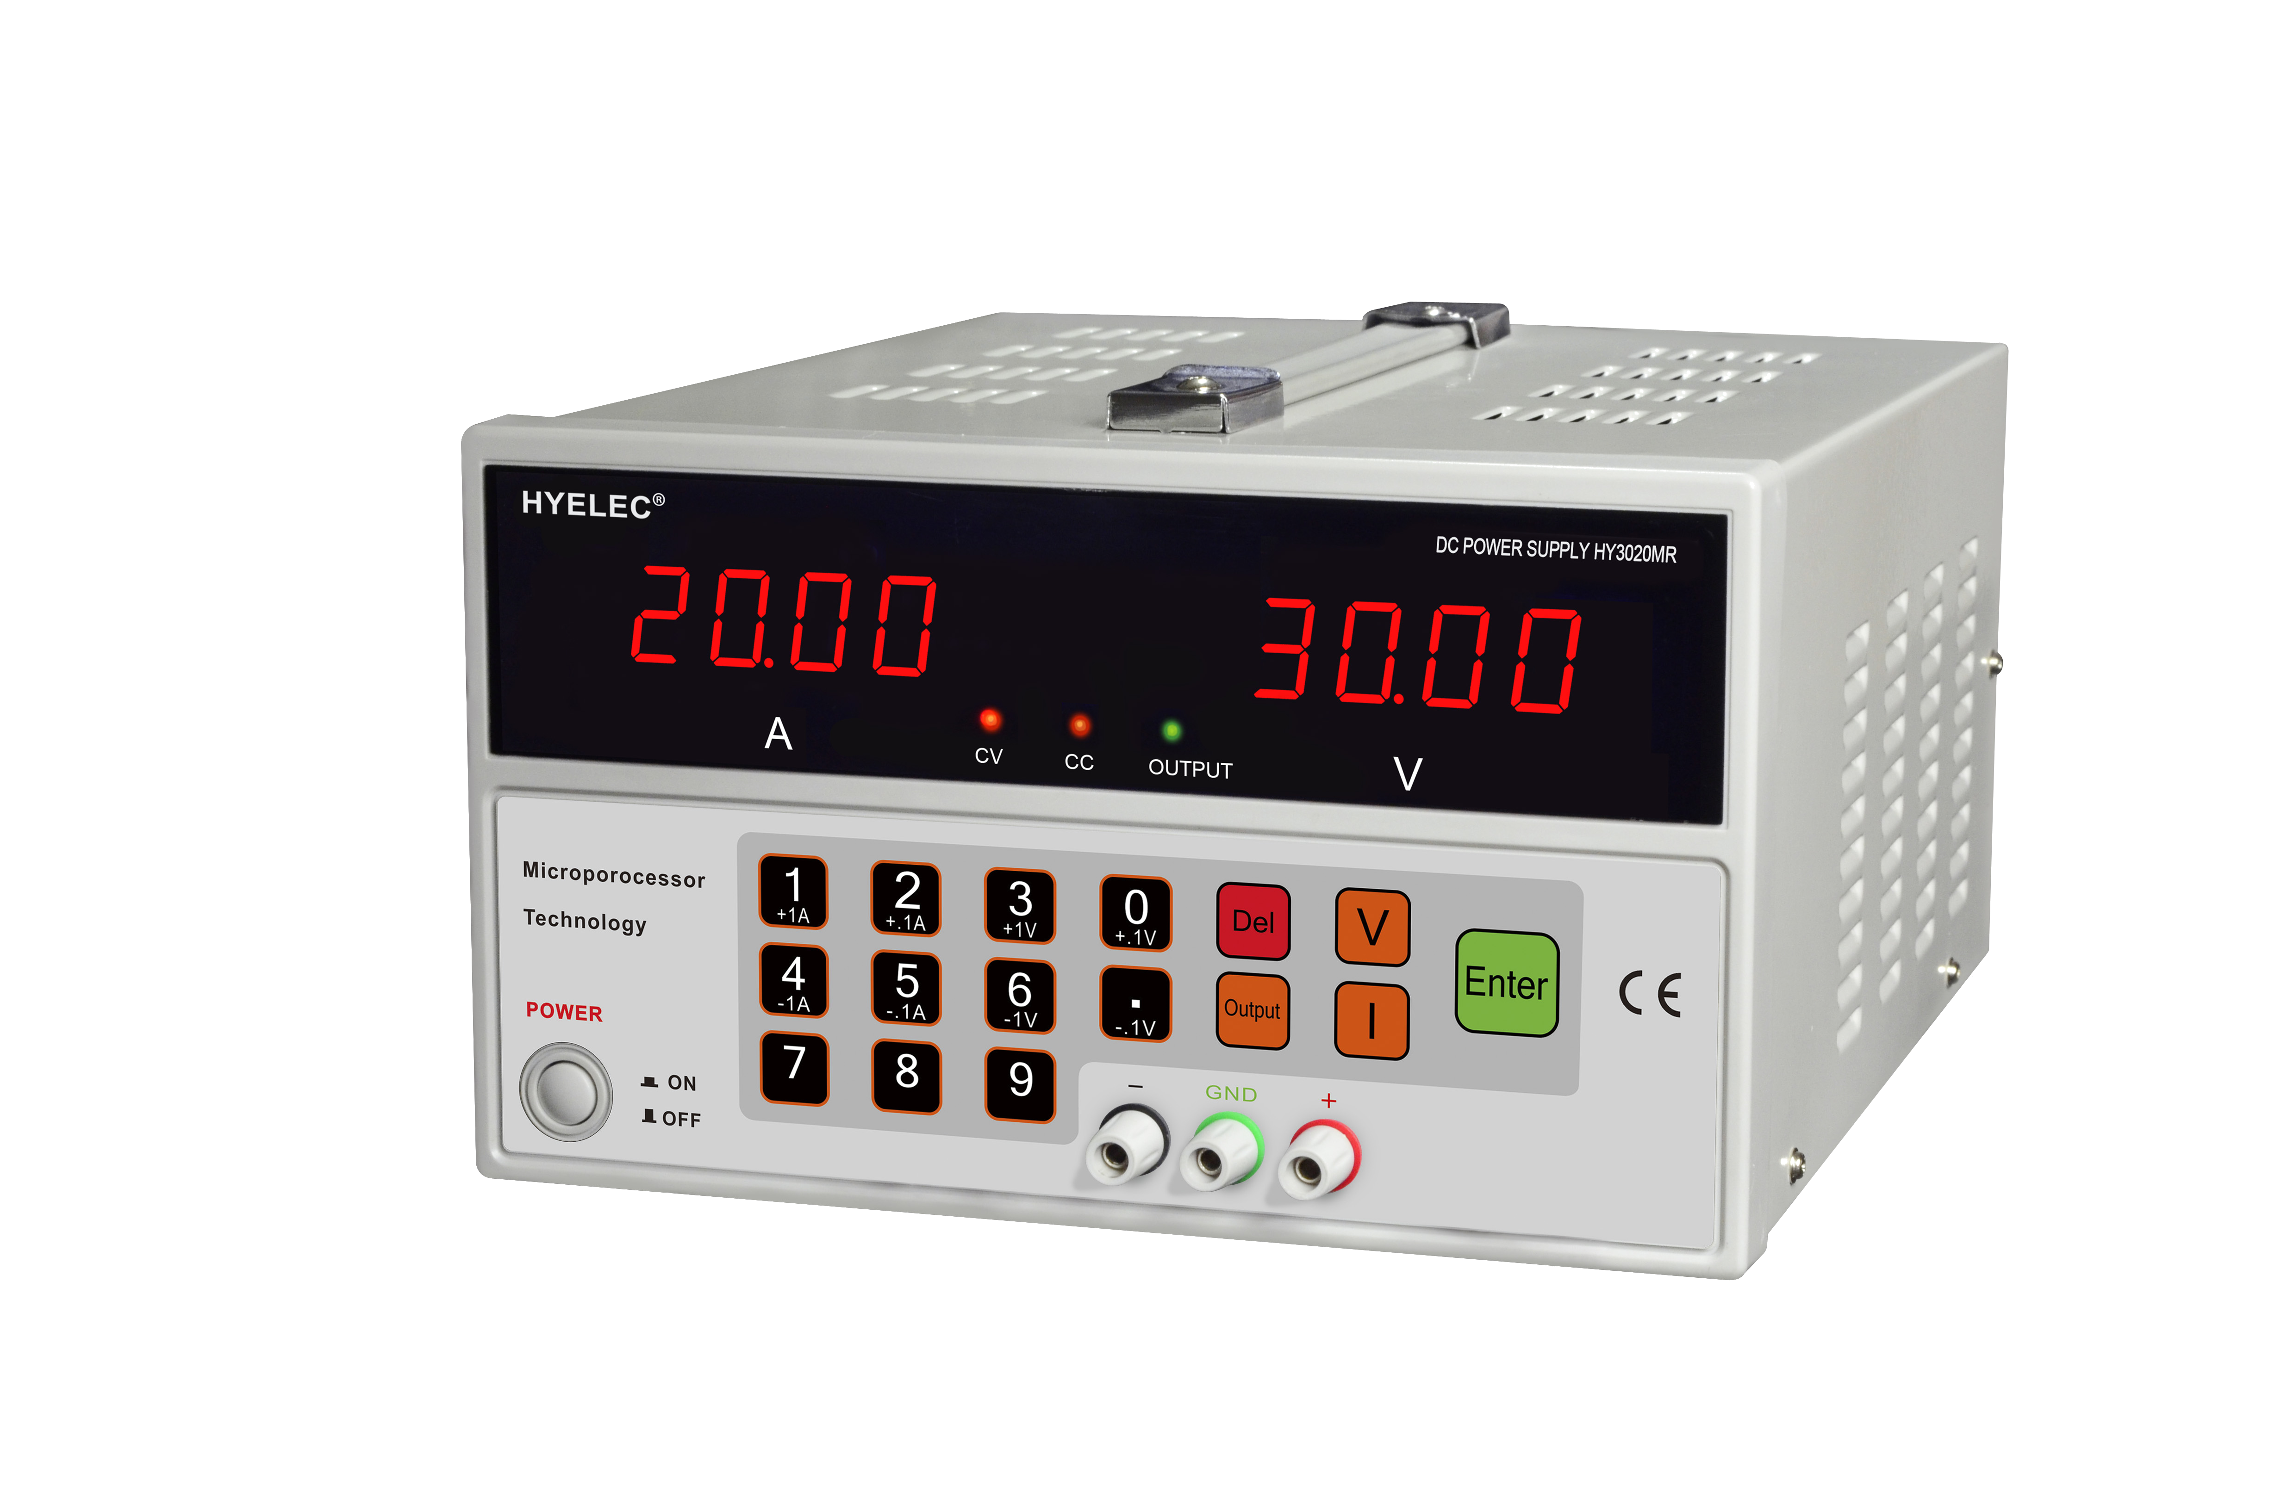
USER’S MANUAL



DIGITAL CONTROL DC REGULATED POWER SUPPLY

DC POWER SUPPLY
BRIEF INTRODUCTION:

HY3010MR and HY3020MR DC power supplies are very stable, it’s voltage and current can be adjusted from zero to rated value. Constant voltage and current can be automatic conversion.
HY3010MR and HY3020MR series are the power supplies that come with steady direct voltage and current. They features digital control and have high precision. With advance controlling technique of microprocessor we can achieve the following functions: the enactment, display, feedback, and protecting of voltage and current. This technique improves the accuracy of enactments and the accuracy of control. Besides, it enables easy to operate and more intuitionistic to see. So this technique avoids the unsteadiness of the enactment point caused by adjust of regular potentiometer, which brings error, excursion, and parts of an apparatus being abrasion. Therefore, the precision and stability of power supply have upgraded greatly. Another characteristic of this power supply is: the enacted voltage can lock in the whole range. This characteristic offers users much more convenience and avoids careless inaccurate operate.

MODELS:
MODEL | HY3010M | HY3020M | HY3010MR | HY3020MR
OUTPUT  VOLTAGE | 0~30V | 0~30V | 0~30V | 0~30V
OUTPUT  CURRENT | 0~10A | 0~20A | 0~10A | 0~20A
USB connection  Function | NO | NO | YES | YES
1 TECHNICAL PARAMETER
1.1 Input voltage: 230V/115V AC+10% 50Hz/60Hz+2Hz
1.2 Line regulation: CV≤0.02%+10mv CC≤0.5%+3mA
1.3 Load regulation: CV≤ 0.02%+10mv CC≤0.5%+10mA
1.4 Ripple and noise: CV≤1mVr.m.s CC≤10mAr.m.s
1.5 Protection: constant current and short-circuit protection
1.6 Voltage indication accuracy: LED+0.2%+5digits
1.7 Current indication accuracy: LED+0.5%+5digits
1.8 Environment: 0+40℃ Relative humidity: <90%

2 Operation
2.1 front panel control illustration see right picture
- Output current indicator
- Output voltage indicator
- Constant Voltage light ( Red light on when reaching constant voltage );
- Constant Current light ( Green light on when reaching constant current );
- Output light ( Green light on when in output status );
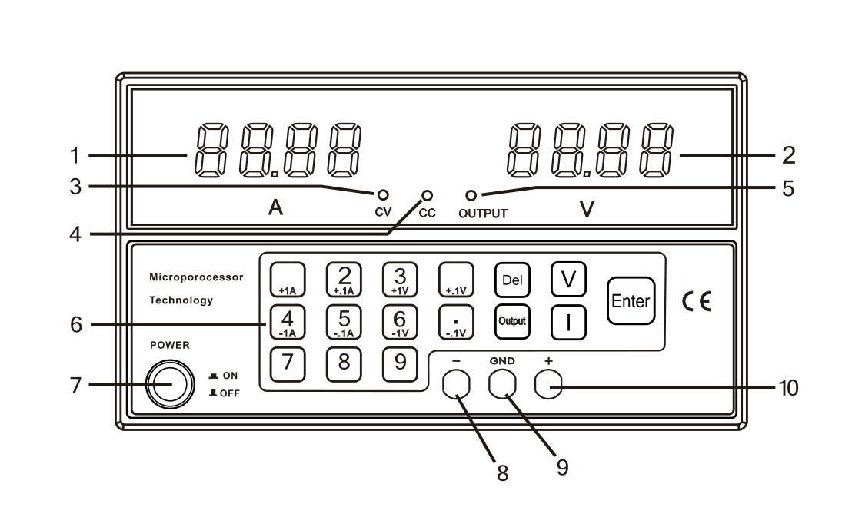
- Push button control panel;
- On / Off button;
- Negative output terminal;
- Ground terminal;
- Positive output terminal;

2.2 USING METHOD

2.2.1 Setting Voltage Output:
Turn power on. Then, press [V] button, Voltage Indicator is ‘zero’ & blinking. Now, set blinking indicator by pressing the desired number to the required voltage, then, press [Enter] button. Voltage is set. E.g.
- To preset a 5.99Volt Value: Press [V] key, then, Press number keys [0] [5] [9][0] then [Enter] OR
Press [V] key, then, [5] [ . ] [9] [9] then [ Enter] keys to complete setting.
- To preset a 29.99 Volt Value: Press [V] key, then, press number keys [2][9][9][9] then [Enter] OR
Press [V] key, then, [2] [9] [ . ] [9] [9] then [ Enter] keys to complete setting.
On top, you can pulse press [+/-0.1V \ +/-1V] key to step tune output voltage, long press can continuously tune
output voltage.

2.2.2 Setting up Limit current protection:
Press [ I ] key, then, key in the value by the number [ -- ] keys the current value, then, press [Enter] to complete. (detail procedures references to set up voltage output above). Or, pulse press [+/- 0.1A \ +/- 1A ] to step tune limit current protection value, long press to continuously tune limit current value.
2.2.3 Output On/Off : Press [ output ] key to activate output, or, de-active output. (Default setting has no output after power on the unit after power off).
2.2.4 To use lock in function for voltage & current: press [ . ] 3 seconds, a ‘beep’ sound indicates that voltage and current are locked-in. To release lock-in, press [ . ] for 3 seconds can release. When voltage and current are locked, all keys will not function except the [ output ] key.
2.2.5 To use the [ Del ] key : When entering the value of voltage and current protection value but before pressing [Enter] key, you can change those value by pressing [ Del ] key to erase initial entered values.
! 3 CAUTION:
3.1 In the event of a short circuit at the output the current will limit at the value set by the current controls, however the unit should be turned off and the short circuit removed before continuing use.
3.2 The mains power must be switched off before servicing and servicing should be referred to a qualified person.
3.3 The unit should be stored in a dry and well ventilated place and the power cord removed if storing for long periods.
4 ACCESSORIES
4.1 Power cord----------------------------one piece
4.2 Instruction manual-------------------one piece
4.3 Control software disc----------------one piece （Only HY3010MR & HY3020MR）

Attached Sheet
I. Software Installation
1.Virtual serial port driver installation
- Open the folder “driver” and double click the installation program 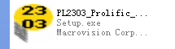。
- After finishing installation, connect the power supply and the computer with usb cable and power on. Check the serial port number: enter the device manager as followed , “COM4” is the serial port number
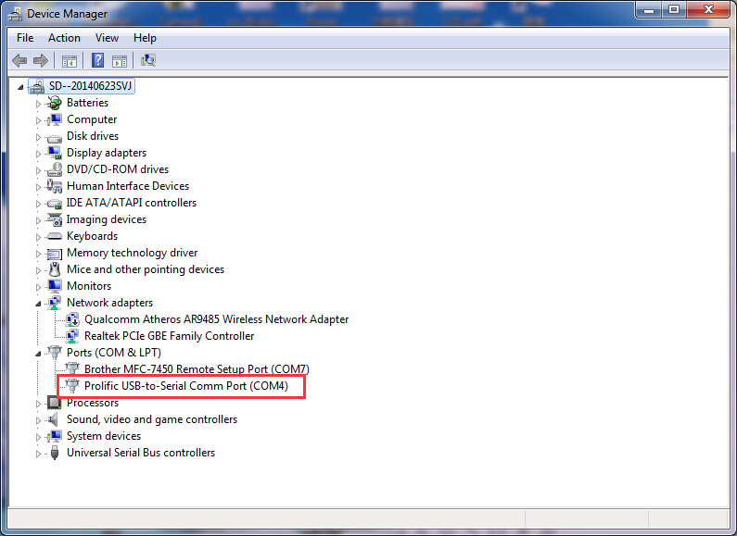
2. Communication software installation
Enter the installation disk and double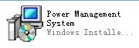，click the communication software installation program and then choose the “next” till finish installation(if errors exist when run the software, please don’t choose non-system disc to install ).
II. Software operation
1.Real-time data setup：
Open the communication software and then choose the model and serial number, click “start” button. Enter the value of current or voltage you need and then click the ISET/VSET to send the value to the Dc power supply.
See attached picture:
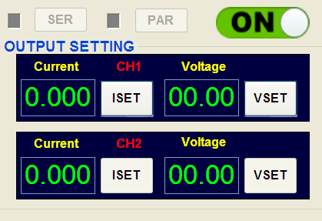

2. Real-time data display:
User can see the real-time voltage and current and the CC/CV condition.
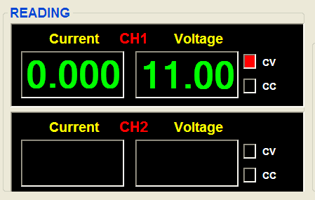

3. Data graph display:
The ordinate is Voltage/Current and the abscissa is the data collection point
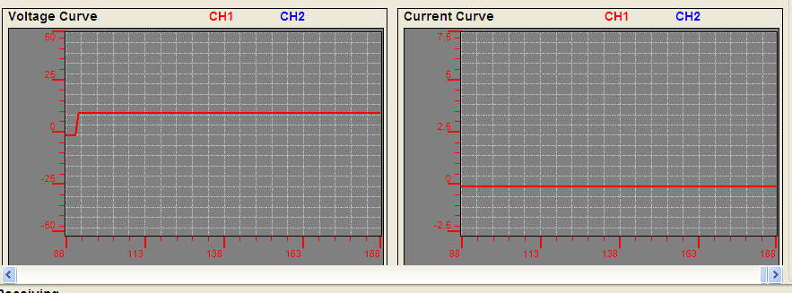
4. Data sheet check:
Click the ”Report” button and get the sheet as followed:
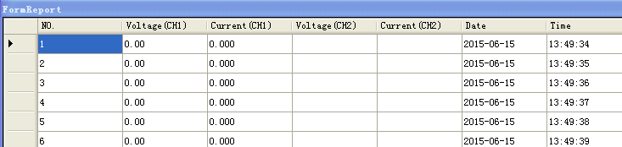
5. Saving data:
Click the “Save” button then enter a name and click the save button.
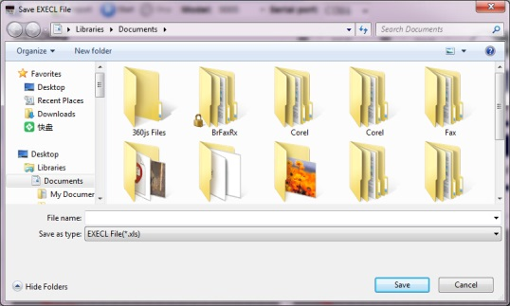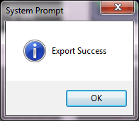
Picture1 Picture 2
6. Data programming:
Open the communication software 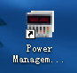, choose the model and serial port number, input the voltage, current and the time, choose “single” or “Repeat” and “Program” . Click the “Start” button  and choose “on”  to run the program.
